**Udacity –sql-project**

**Date created** : 03/05/2020

**Project Title:** **INVESTIGATE A RELATIONAL DATABASE**

**Description:**

I used SQL to explore a database related to movie rentals. I wrote SQL code to run SQL queries and answer questions about the database.

The project end-result is a presentation of four slides. Each slide

: ● Has a question of interest

. ● Has a supporting SQL query needed to answer the question

. ● Has a supporting visualization created using the final data of my SQL query that answers my question of interest.

The four questions of interest are:

● *What are the most successful categories among the family movies ?

* ● What is the distribution of family-friendly movies among the film categories and rental duration categories ?

● How does the two stores compare in their count of rental orders ?

● Who are the top 10 paying customers ?

How many did each paid in total ?

**Credits:**

Thanks to the Udacity team for this great project!

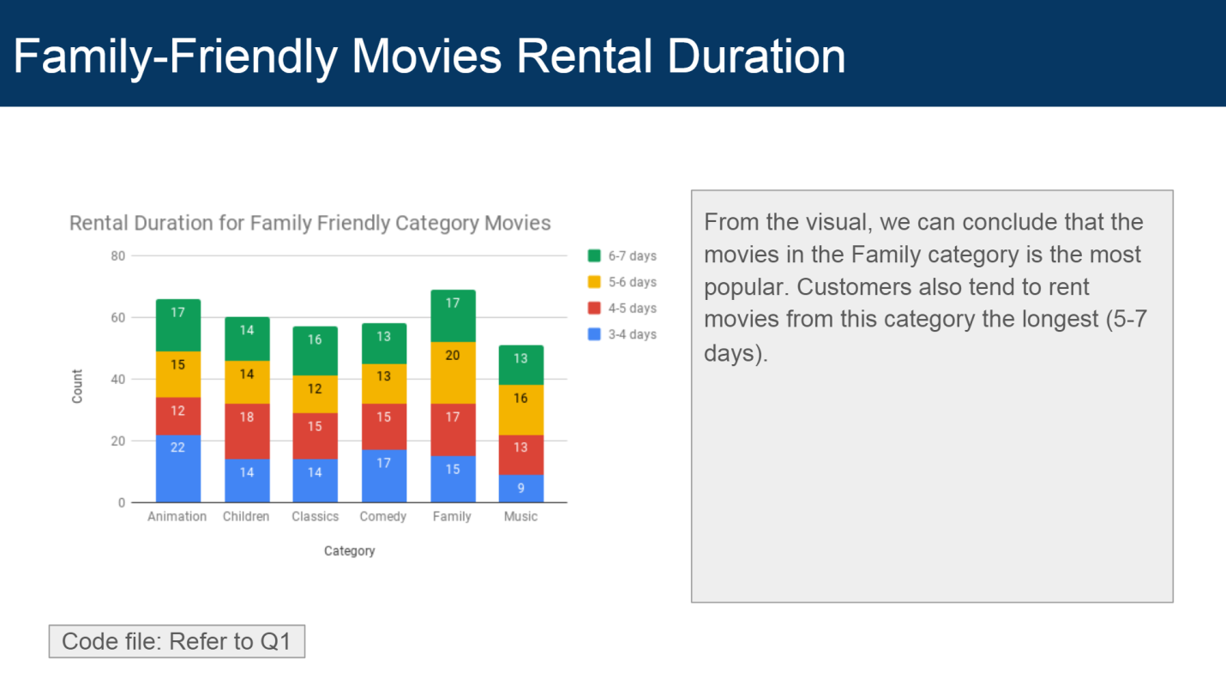

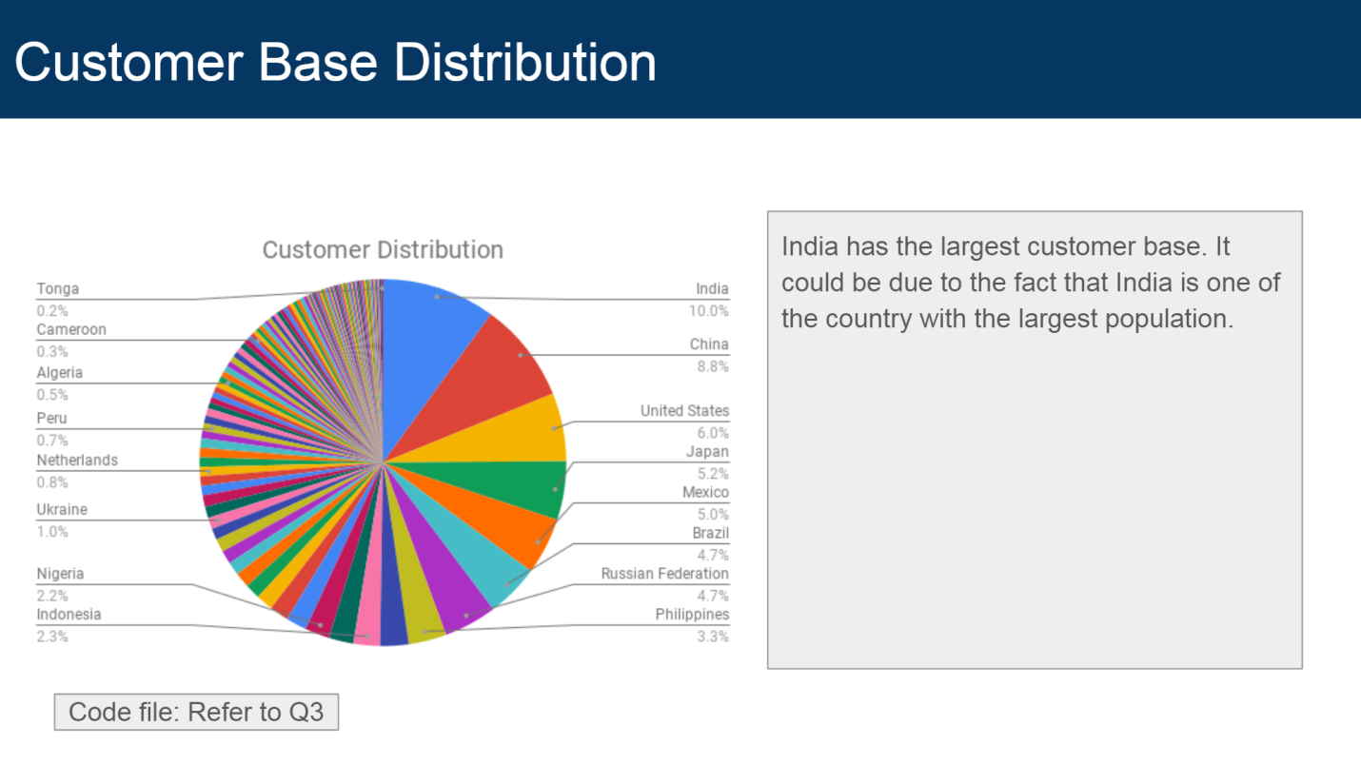

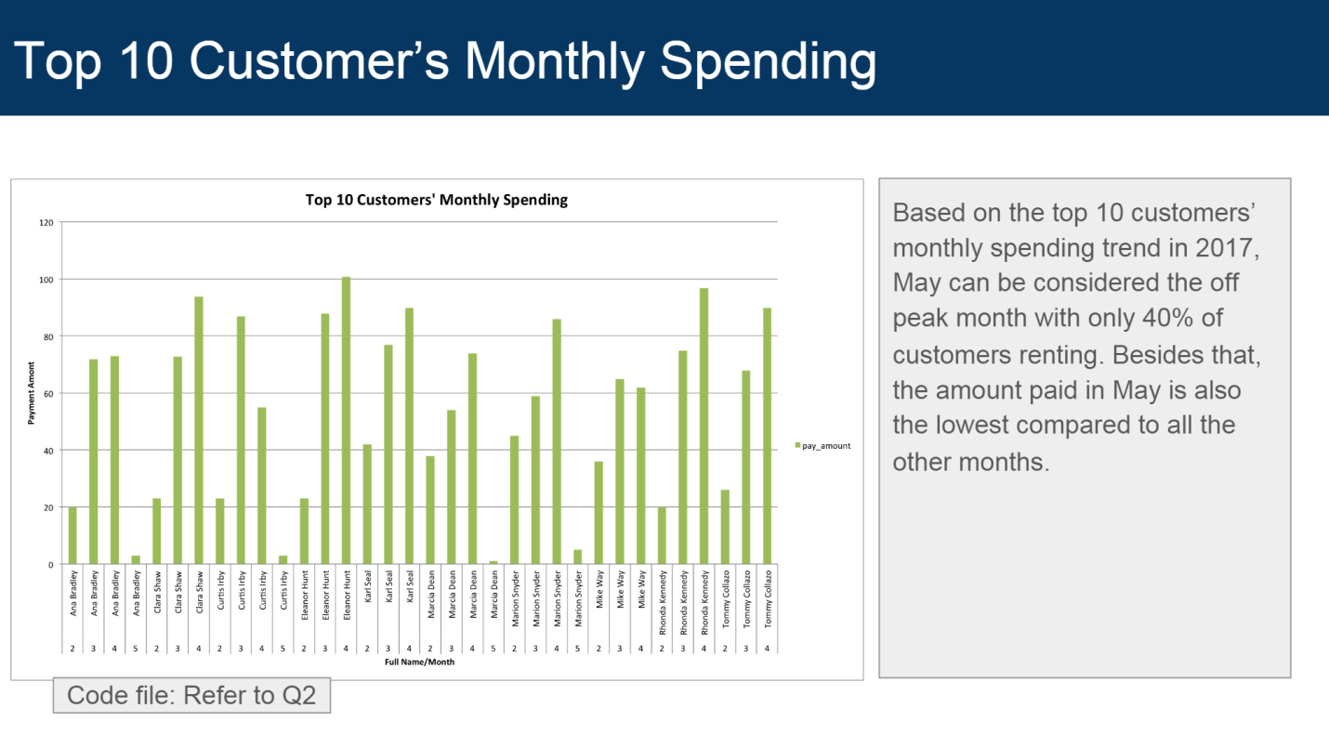

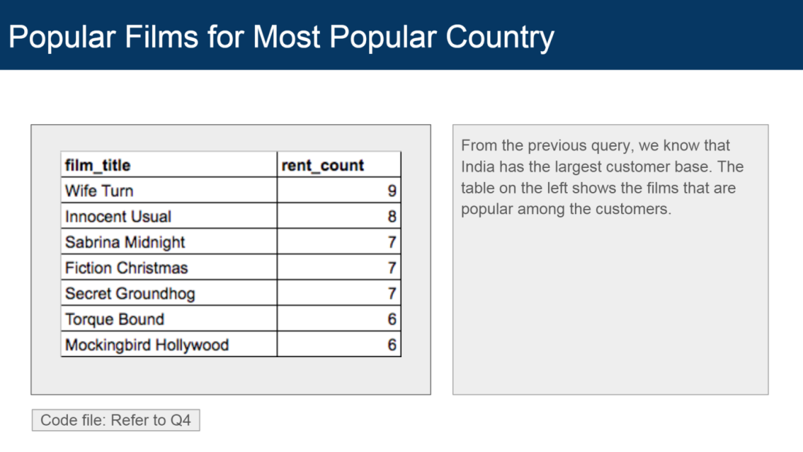

|  |  |
| --- | --- |
| /*Questions solutions*/ | |
|  | |  | |
|  | | /* Q1 - What is the number of movies in each family-friendly category?*/ | |
|  | | WITH | |
|  | | updated_cats AS | |
|  | | (SELECT fc.film_id, c.name | |
|  | | FROM film_category fc | |
|  | | JOIN category c | |
|  | | ON c.category_id = fc.category_id), | |
|  | | updated_qrental AS | |
|  | | (SELECT DISTINCT f.title AS film_title, uc.name, f.rental_duration, ntile(4) OVER | |
|  | | (PARTITION BY f.rental_duration) AS standard_quartile | |
|  | | FROM film f | |
|  | | JOIN updated_cats uc | |
|  | | ON uc.film_id = f.film_id | |
|  | | WHERE uc.name IN ('Family', 'Children', 'Music', 'Animation', 'Comedy','Games') | |
|  | | ORDER BY 4,3) | |
|  | |  | |
|  | | SELECT name, count(*) | |
|  | | FROM updated_qrental | |
|  | | GROUP BY 1 | |
|  | | ORDER BY 2; | |
|  | |  | |
|  | |  | |
|  | | /* Q2 - What is the number of rental orders for each store per month?*/ | |
|  | | SELECT Date_TRUNC('month', r.rental_date) Rental_month, i.store_id, COUNT(*) Count_rentals | |
|  | | FROM rental r | |
|  | | LEFT JOIN inventory i | |
|  | | ON i.inventory_id = r.inventory_id | |
|  | | GROUP BY 1,2 | |
|  | | ORDER BY 3 DESC; | |
|  | |  | |
|  | |  | |
|  | |  | |
|  | | /* Q3 - What is the number total number of rentals for the top 10 customers based on the highest rental orders per month?*/ | |
|  | |  | |
|  | | WITH | |
|  | | top_10 AS | |
|  | | (SELECT c.customer_id, CONCAT (c.first_name, ' ', c.last_name) fullname, COUNT(*) pay_countpermon, SUM(p.amount) | |
|  | | FROM payment p | |
|  | | JOIN customer c | |
|  | | ON p.customer_id = c.customer_id | |
|  | | GROUP BY 1,2 | |
|  | | ORDER BY 3 DESC, 2 | |
|  | | LIMIT 10) | |
|  | |  | |
|  | | SELECT fullname, SUM(pay_countpermon) | |
|  | | FROM (SELECT DATE_TRUNC('month', p.payment_date) pay_mon, t.fullname, COUNT(DATE_TRUNC('month', p.payment_date)) pay_countpermon, SUM(p.amount) | |
|  | | FROM payment p | |
|  | | JOIN top_10 t | |
|  | | ON p.customer_id = t.customer_id | |
|  | | GROUP BY 1,2 | |
|  | | ORDER BY 2,3 DESC) sub | |
|  | | GROUP BY 1 | |
|  | | ORDER BY 2 DESC; | |
|  | |  | |
|  | |  | |
|  | |  | |
|  | | /* Q4 - Who are the customers with highest difference in rental orders from a month to another?*/ | |
|  | | WITH | |
|  | | top_10 AS | |
|  | | (SELECT c.customer_id, CONCAT (c.first_name, ' ', c.last_name) fullname, COUNT(*) pay_countpermon, SUM(p.amount) total_rents | |
|  | | FROM payment p | |
|  | | JOIN customer c | |
|  | | ON p.customer_id = c.customer_id | |
|  | | GROUP BY 1,2 | |
|  | | ORDER BY 3 DESC, 2 | |
|  | | LIMIT 10) | |
|  | |  | |
|  | | SELECT DATE_TRUNC('month', p.payment_date) pay_mon, t.fullname, COUNT(DATE_TRUNC('month', p.payment_date)) pay_countpermon, SUM(p.amount), SUM(p.amount) - LAG(SUM(p.amount)) OVER (PARTITION BY t.fullname ORDER BY DATE_TRUNC('month', p.payment_date)) difference | |
|  | | FROM payment p | |
|  | | JOIN top_10 t | |
|  | | ON p.customer_id = t.customer_id | |
| GROUP BY 1,2; | |

THANK YOU

|  |
| --- |
|  |
|  |
|  |  |
|  |  |
|  |  |
|  |  |
|  |  |
|  |  |
|  |  |
|  |  |
|  |  |
|  |  |
|  |  |
|  |  |
|  |  |
|  |  |
|  |  |
|  |  |
|  |  |
|  |  |
|  |  |
|  |  |
|  |  |
|  |  |
|  |  |
|  |  |
|  |  |
|  |  |
|  |  |
|  |  |
|  |  |
|  |  |
|  |  |
|  |  |
|  |  |
|  |  |
|  |  |
|  |  |
|  |  |
|  |  |
|  |  |
|  |  |
|  |  |
|  |  |
|  |  |
|  |  |
|  |  |
|  |  |
|  |  |
|  |  |
|  |  |
|  |  |
|  |  |
|  |  |
|  |  |
|  |  |
|  |  |
|  |  |
|  |  |
|  |  |
|  |  |
|  |  |
|  |  |
|  |  |
|  |  |
|  |  |
|  |  |
|  |  |
|  |  |
|  |  |
|  |  |
|  |  |
|  |  |
|  |  |
|  |  |
|  |  |